**1. Kubernetes Important Concepts for Application Deployments -Introduction**

--- **Reference** - <https://github.com/stacksimplify/aws-eks-kubernetes-masterclass/tree/master/05-Kubernetes-Important-Concepts-for-Application-Deployments>

--- in this lecture, we will learn about few important kubernetes concepts which are important for application deployment on kubernetes cluster.

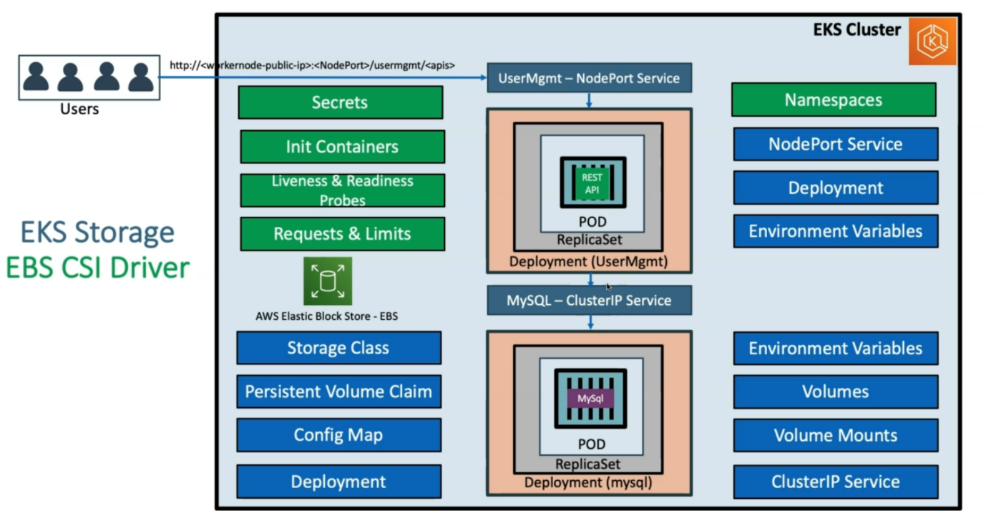

--- **secrets** - whatever the db password we provided in the service files. Why can’t we send it in the encrypted format? For this purpose, we will use kubernetes secrets.

--- **init containers** – before mysql db started, our application got started and it did find mysql so it restarted again. To ensure that the mysql db to come up and then start the application.

--- **liveness and Rediness probes** – the traffic can be allowed to respective pods only when the liveness and rediness probes are successful. Those we need to implement for our application.

--- **Requests and limits** – how much cpu and memory in the kubernetes cluster should be taken by our respective application

--- **NameSpace** – in EKS cluster you have stagging, development, QA environment. you can create namespaces for dev, QA, stagging and deploy the same application in those namespaces. You can allocate limited resources to the namespaces.